
Introduction to Electrical Engineering
Lab Report
Name: Pranesh Chowdhury
ID: 202003112
Course ID: 112
Section: 2
Experiment No: 6
Experiment Name: Verification of Reciprocity Theorem

Objective:
In this experiment, we are going to verify the reciprocity theorem. The reciprocity theorem works by the current 'I' in any branch of a network, due to a single voltage source 'E' anywhere else in the network, will equal the current through the branch in which the source was originally located if the source is placed in the branch in which the current 'I' was originally measured.
List of Equipment:
- Wires
- Resistors
- PSIM Software
- DC Power Supply
- Ammeters
- Voltmeters
Circuit Diagram:
Circuit 1:
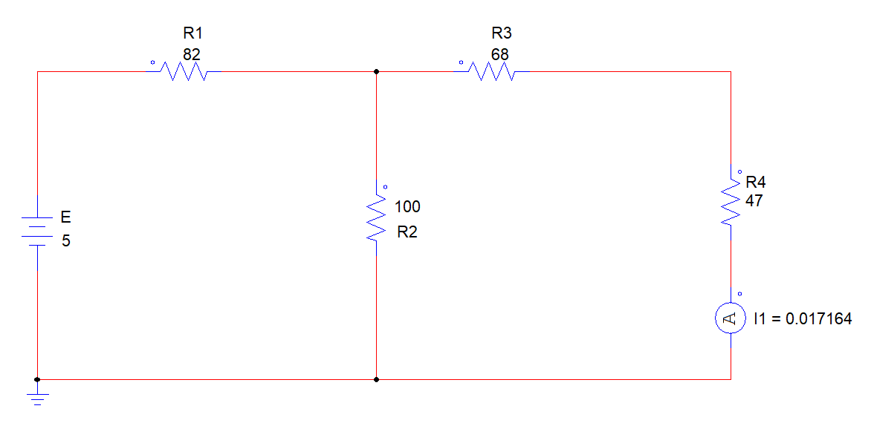
Here,
Rt = R1 + {R2 || (R3+R4)}
- 82 + {100 || (68+47)} ohms
- 135.49 ohms
Is = E / Rt
- 5V / 135.49 ohms
- 0.036903535 A
I = {(100 * 0.036903535) / (100+68+47)} A
- 0.017164435 A
Circuit 2:
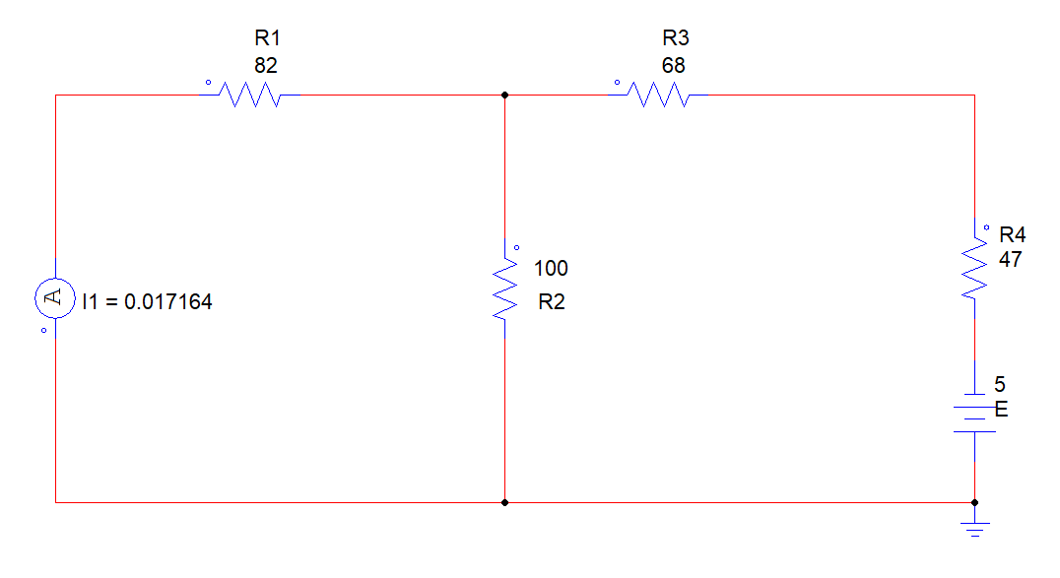
Here,
Rt = (R1 || R2) +R3+R4
- {(82 || 100) +68+47} ohms
- 160.0549451 ohms
Is= E / Rt
- 5V/160.0549451 A
- 0.031239272 A
I = {100/ (100+82)} ohms/0.031239272 A
- 0.017164435 A
From Circuit 1 & 2 we can see that both current values are same. So, the reciprocity theorem is satisfied here.
Circuit 3:
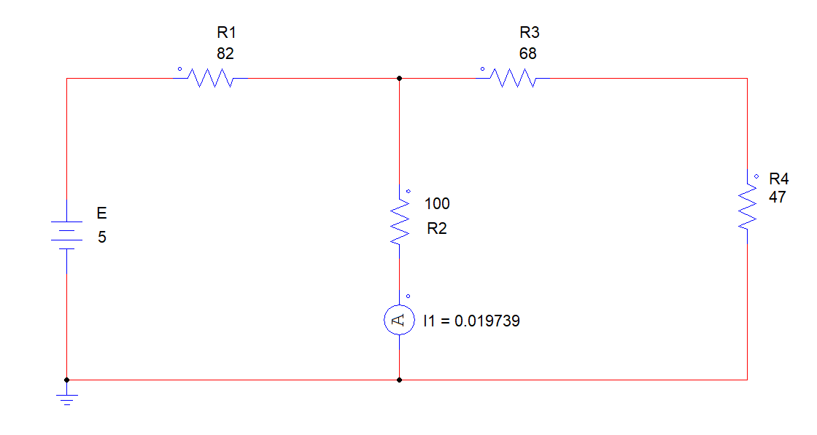
Here,
Rt = {R1 (R3+R4) || R3}
- 135.488372 Ohms
Is = E / Rt
- 5 / 135.488372 A
- 0.0369034 A
I2 = (115 + 0.0369034) / (115 + 100)
- 0.01973881 A

Circuit 4:
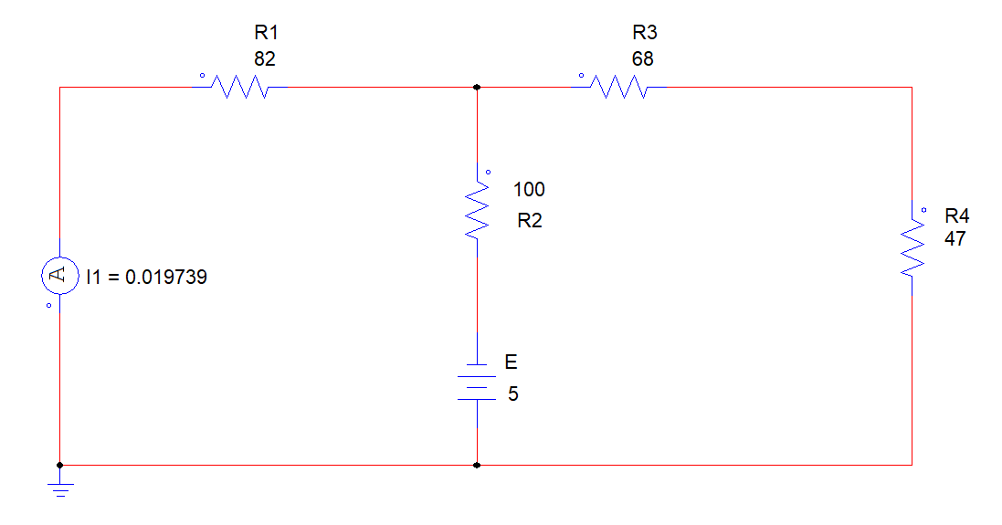
Here,
Rt = [{R1 || (R4 + R3)} + R2]
- 147.8680203 Ohms
Is = E / Rt
- 5 / 147.8680203 A
- 0.0338139 A
I = (115 * 0.0338139) / (115 + 82)
- 0.019739 A
From Circuit 3 & 4 we can see that both current values are same. So, the reciprocity theorem is satisfied here.
Discussion:
We have to be taken care whereas setting batteries and ammeter since able to get default values. We evaluate the four circuits using PSIM software. I faced some troubles in this portion by getting default values since of relocation of ammeter and battery.

